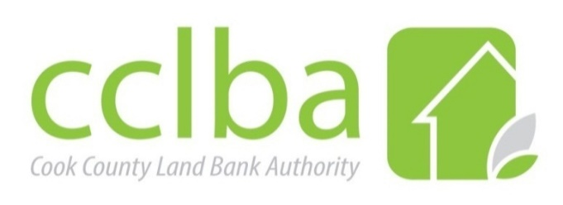

Cook County Land Bank Authority - Land Transactions Committee Meeting
Wednesday, August 14, 2024, at the hour of 1:00PM CST
69 W. Washington Street, Chicago on the 22nd Floor, Conference Room F

- Call to Order and Roll Call

- Public Speakers
If you would like to register to be a public speaker, please email Jennifer Hubbard-Lyles at jennifer@cookcountylandbank.org by 3:00 PM CST on Tuesday, August 13, 2024. Indicate which topic on the agenda you wish to make a comment on. Please note: each registered speaker has three (3) minutes.

- 9112 Belden Avenue, Franklin Park, IL 60131
Approval of Resolution 24-17 to enter into a Purchase Sale Agreement for $175,000 with 9112 Belden Avenue, LLC for the property at 9112 Belden Avenue, Franklin Park, IL 60131
Elisha Sanders - Manager, Property Acquisition
  - Jaroslaw Momotko

- Consent Agenda
- Approval of June 12, 2024, Cook County Land Bank Land Transactions Committee meeting minutes.
- Approval of June 2024 Transaction Reports.
- Approval of July 2024 Transaction Reports.

- Other Discussion

- Adjournment

